 | TM271: Machine Learning and Deep Learning  Tutor-Marked Assignment (TMA) Spring 24/25

Cut-Off Date: Based on the Published Deadline. Total Marks: 100 Marks (turned to 15 Marks) Contents
Warnings and Declaration…………………………………….………………………………......1

Part A .…..……………….…………………………………. ………………………………...…..2

Part B .…..……………….…………………………………. ………………………………...…..2

Part C .…..……………….…………………………………. ………………………………...…..3

Plagiarism Warning:

As per AOU rules and regulations, all students are required to submit their own TMA work and avoid plagiarism. The AOU has implemented sophisticated techniques for plagiarism detection. You must provide all references in case you use and quote another person's work in your TMA. You will be penalized for any act of plagiarism as per the AOU's rules and regulations.

Declaration of No Plagiarism by Student (to be signed and submitted by student with TMA work):

I hereby declare that this submitted TMA work is a result of my own efforts and I have not plagiarized any other person's work. I have provided all references of information that I have used and quoted in my TMA work.

Name of Student:…………………………….. Signature:…………………………………………... Date:…………………………………………………

import pandas as pd
from sklearn.preprocessing import LabelEncoder, StandardScaler
from sklearn.model_selection import train_test_split
from sklearn.ensemble import RandomForestClassifier
from sklearn.model_selection import GridSearchCV
from sklearn.metrics import accuracy_score, precision_score, recall_score, f1_score, roc_auc_score, classification_report, confusion_matrix
from imblearn.over_sampling import SMOTE

df = pd.read_csv("./dataset/WA_Fn-UseC_-Telco-Customer-Churn.csv")

# Part A Loading dataset and preprocessing

## Question No 1:

### Display the names of columns
print(df.columns)

### Display the number of rows and columns (rows, columns)
print(df.shape)

### The first 10 rows
print(df.head(10))

### The last 10 rows
print(df.tail(10))

## Question No 2:

### Display basic statistics of the dataset
print(df.describe())

### identifying the missing data
print(df.dtypes)
print(df.isnull().sum()) # There in no missing data

### Identifying imbalanced data in Churn column
print(df['Churn'].value_counts(normalize=True)) # 26.5% of the customers have churned, while 73.5% have not churned.

## Question No 3:

### Handling TotalCharges => it has object dtype, so i'll Convert it to numirec values
print(df['TotalCharges'].unique()) # Before Converting
df['TotalCharges'] = pd.to_numeric(df['TotalCharges'], errors='coerce')
df['TotalCharges'] = df['TotalCharges'].fillna(df['TotalCharges'].median())
print(df['TotalCharges'].unique()) # After Converting

### There is no need for customerID column in prediction, so i'll drop it
df.drop('customerID', axis=1, inplace=True)
print(df.columns) # customerID column is dropped

### Encode categorical features using one-hot encoding
categorical_features = df.select_dtypes(include=['object']).columns.tolist()
categorical_features.remove('Churn') # Remove the label
df = pd.get_dummies(df, columns=categorical_features, drop_first=True) # One-hot encoding
df = df.astype({col: int for col in df.columns if df[col].dtype == 'bool'}) # Converting the True and False values to 0s and 1s
print(df.head())

### Encode the lebel (yes = 1, no = 0)
label_encoder = LabelEncoder()
df['Churn'] = label_encoder.fit_transform(df['Churn'])
print(df['Churn']) # Encoded

### Normalize numerical features
scaler = StandardScaler()
numerical_features = ['tenure', 'MonthlyCharges', 'TotalCharges']
df[numerical_features] = scaler.fit_transform(df[numerical_features])

### Split the Data into Dependent and Independent Variables
x = df.drop('Churn', axis=1).copy()
y = df['Churn'].copy()
print(x)
print(y)

## Question No 4
x_train, x_test, y_train, y_test = train_test_split(
x, y, test_size=0.2, random_state=42, stratify=y
)

### Apply SMOTE
smote = SMOTE(random_state=42)
x_train_resampled, y_train_resampled = smote.fit_resample(x_train, y_train)
print(y_train_resampled.value_counts())

## Question No 5

### I'll use random forest Beacause of:
### - 1. It can handle both numerical and categorical data.
### - 2. It is robust to overfitting.
### - 3. It can handle imbalanced datasets well.
### - 4. Insensitive for scaling

### Train the Random Forest Classifier
rf_clf = RandomForestClassifier(n_estimators=100, random_state=42)
rf_clf.fit(x_train_resampled, y_train_resampled)

## Question No 6
y_pred = rf_clf.predict(x_test)
y_pred_proba = rf_clf.predict_proba(x_test)[:, 1] # For AUC-ROC

### Metrics
accuracy = accuracy_score(y_test, y_pred)
precision = precision_score(y_test, y_pred)
recall = recall_score(y_test, y_pred)
f1 = f1_score(y_test, y_pred)
auc = roc_auc_score(y_test, y_pred_proba)

print("Confusion Matrix:\n", confusion_matrix(y_test, y_pred))
print("\nClassification Report:\n", classification_report(y_test, y_pred))
print(f"Accuracy: {accuracy:.4f}")
print(f"Precision: {precision:.4f}")
print(f"Recall: {recall:.4f}")
print(f"F1-score: {f1:.4f}")
print(f"AUC-ROC: {auc:.4f}")

### Accuracy will be misleading because of the imbalanced data
### when missing a churner means losing a customer, for that recall will be more important
### It measures how many actual churners were correctly predicted

## Question No 7
param_grid = {
'n_estimators': [100, 200],
'max_depth': [10, 20, None],
'min_samples_split': [2, 5],
'min_samples_leaf': [1, 2],
'max_features': ['sqrt', 'log2'],
'bootstrap': [True]
}

rf= RandomForestClassifier(random_state=42)

grid_search = GridSearchCV(
estimator=rf,
param_grid=param_grid,
cv=5,
scoring='f1',
n_jobs=-1,
verbose=1
)

grid_search.fit(x_train_resampled, y_train_resampled)

best_rf_grid = grid_search.best_estimator_
print("Best Parameters Found:\n", grid_search.best_params_)

def evaluate_model(name, model, x_test, y_test):
y_pred = model.predict(x_test)
y_pred_proba = model.predict_proba(x_test)[:, 1]

print(f"--- {name} ---")
print("Accuracy:", accuracy_score(y_test, y_pred))
print("Precision:", precision_score(y_test, y_pred))
print("Recall:", recall_score(y_test, y_pred))
print("F1 Score:", f1_score(y_test, y_pred))
print("AUC-ROC:", roc_auc_score(y_test, y_pred_proba))
print("Classification Report:\n", classification_report(y_test, y_pred))

evaluate_model("Original Random Forest", rf_clf, x_test, y_test)

evaluate_model("Tuned Random Forest", best_rf_grid, x_test, y_test)

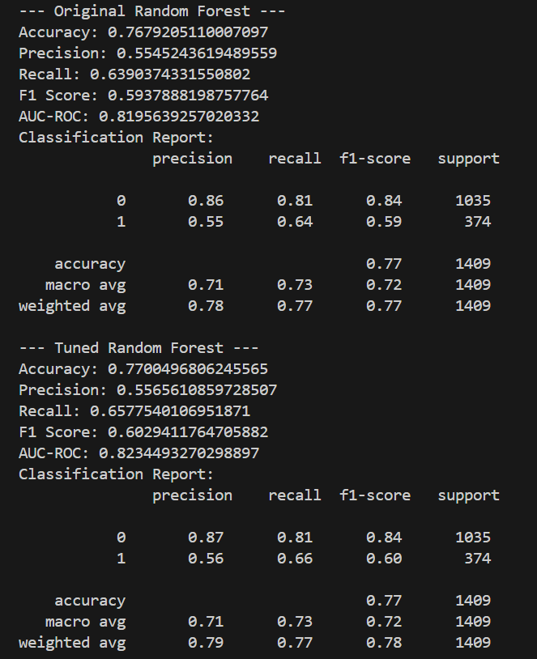

Part C:

Certificate:
